

Four Fundamental Subspaces
Professor. Prashanth L A
Department of Computer Science and Engineering
Indian Institute of Technology, Madras
Four Fundamental Subspaces
Welcome to week 3 of machine learning foundations. In this week, as well as subsequent 3 weeks, we will be looking at topics in linear algebra, specifically those that apply, that would be helpful in understanding machine learning. We will start with the first lecture today, which will be recap for some of you, and may be new for some; the idea is to understand four fundamental subspaces associated with any matrix, which is namely column space, null space, the row space and the left null space of a matrix.
We will be defining those, these four subspaces and then try to calculate them for a simple, for a given matrix and try to understand the relation between the dimensions of these four subspaces and how they relate to the number of rows and columns of a matrix.
(Refer Slide Time: 1:11)
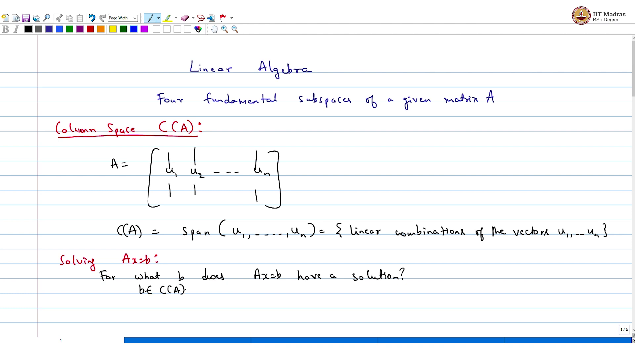
We will start with recap today, will be looking at the four fundamental subspaces for given matrix A. First one is column space, C of A. If you, I mean for simplicity, suppose, A is this matrix with columns you u₁, u₂, till u_{n}. So, these these are the columns, then the column space of A is the span of these columns, which is the, which is all linear combinations of the vectors u1 until un.
And column space has connections to solving Ax = b, as you know. So, if I want to look at solving Ax = b, then column space plays a role. For example, one could ask the question, for what b does Ax = b have a solution? And, the answer is for all b belonging to the column space of A.
(Refer Slide Time: 3:08)
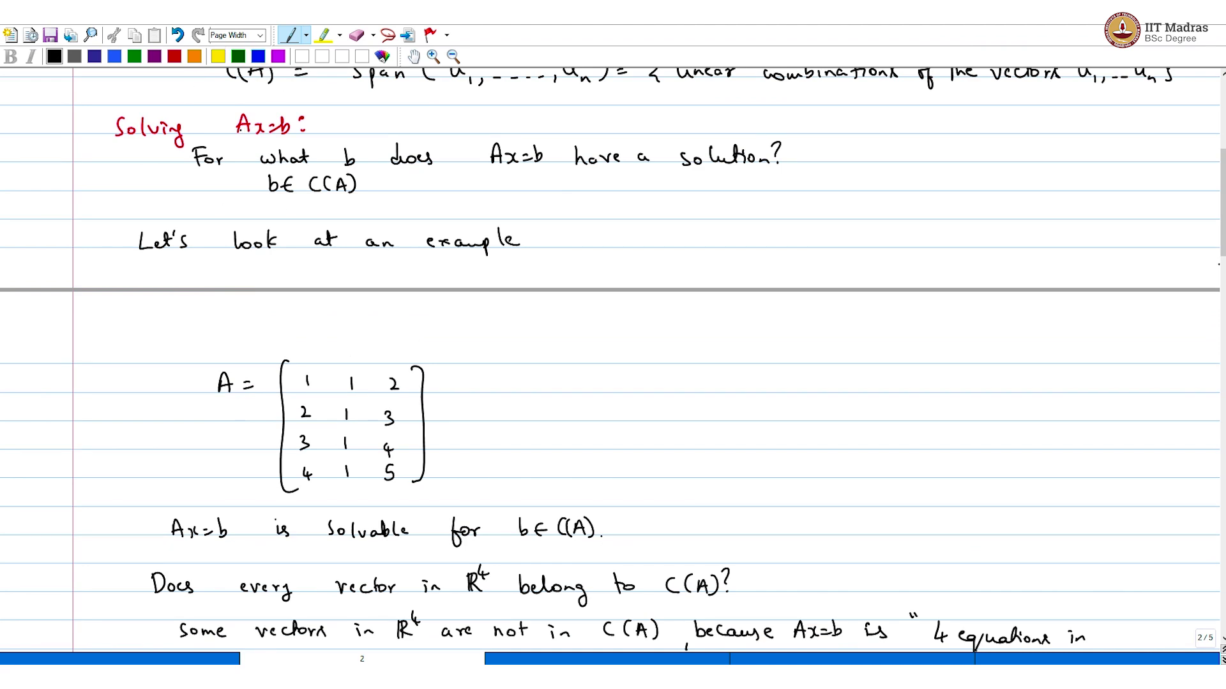
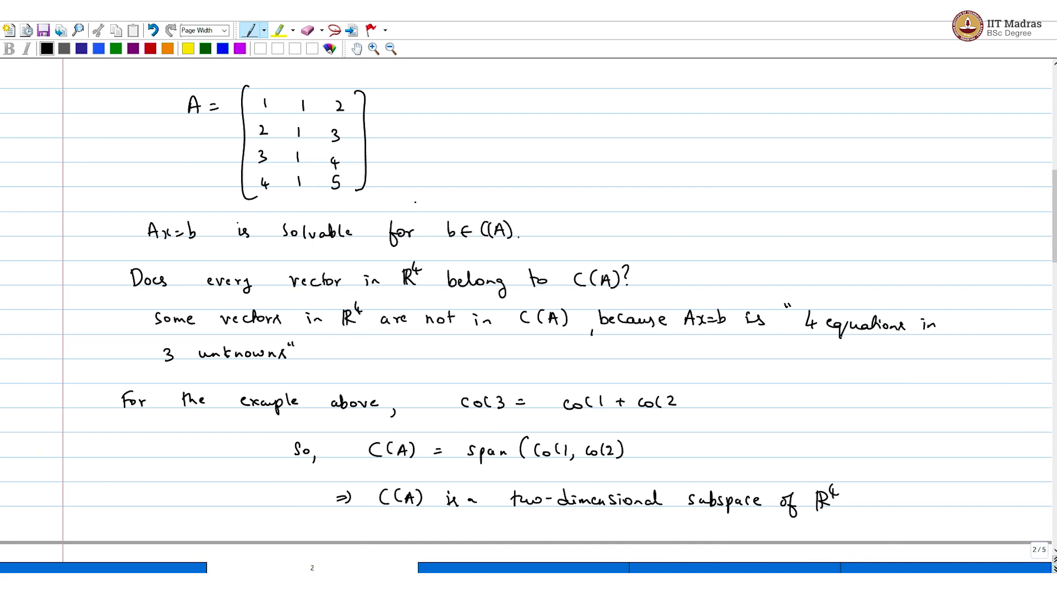
For example, I will look at any, let us look at an example. Suppose you take the matrix, so, Ax = b is solvable, for b belonging to column space of A. The question is does every vector in R4, belong to column space of A? The answer is no. Some vectors in R power 4 are not in the column space of A because, because what you have is, we have 4 equations in 3 unknowns. That is what we have, we have 4 equations in 3 unknowns.
Let us put it this way because Ax = b is 4 equations in 3 unknowns. For this example, what is, for the example above, if you observe column space of A, if you observe, column 3 is just column 1 + column 2. So, column space of A is span of, column 1, column 2 implies column space of A is a two-dimensional subspace of what? Of R4. Hope this is clear.
Now we will go on to the very next space. So, just a quick recap. So, column space is a set of all linear combinations of the columns of a particular matrix. And that plays a role because you want to solve Ax = b. And if you want to know for what b, this is solvable, then b has to be in the column space of A. And we just saw an example, where every b, every possible four-dimensional Euclidean vector is not in the column space of this matrix.
(Refer Slide Time: 6:20)
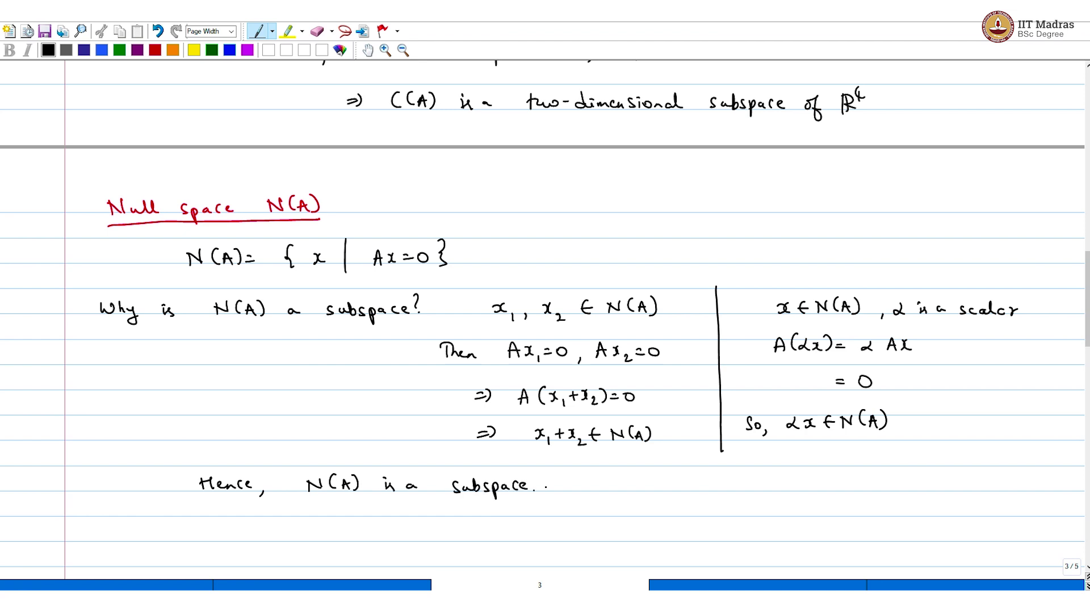
And the very next subspace, which is important is the null space. So, the null space of A is the set of all x such that Ax = 0. Now why is it a subspace? Why is N of A a subspace? It is a subspace, I mean, what are the two conditions that you want to verify? Let us say, if you take two vectors, let us say x1 and x2, both belong to a null space of A. Then Ax1 = 0 and Ax2 = 0 implies A of x1 + x2 = 0 implies x1 + x2 belongs to the null space of A. That is the first thing.
Second thing is, suppose you have a vector here, then what is A of α x, α is a scalar, is α times Ax = 0. So, α x also belongs. Hence, N of A is a subspace.
(Refer Slide Time: 8:02)
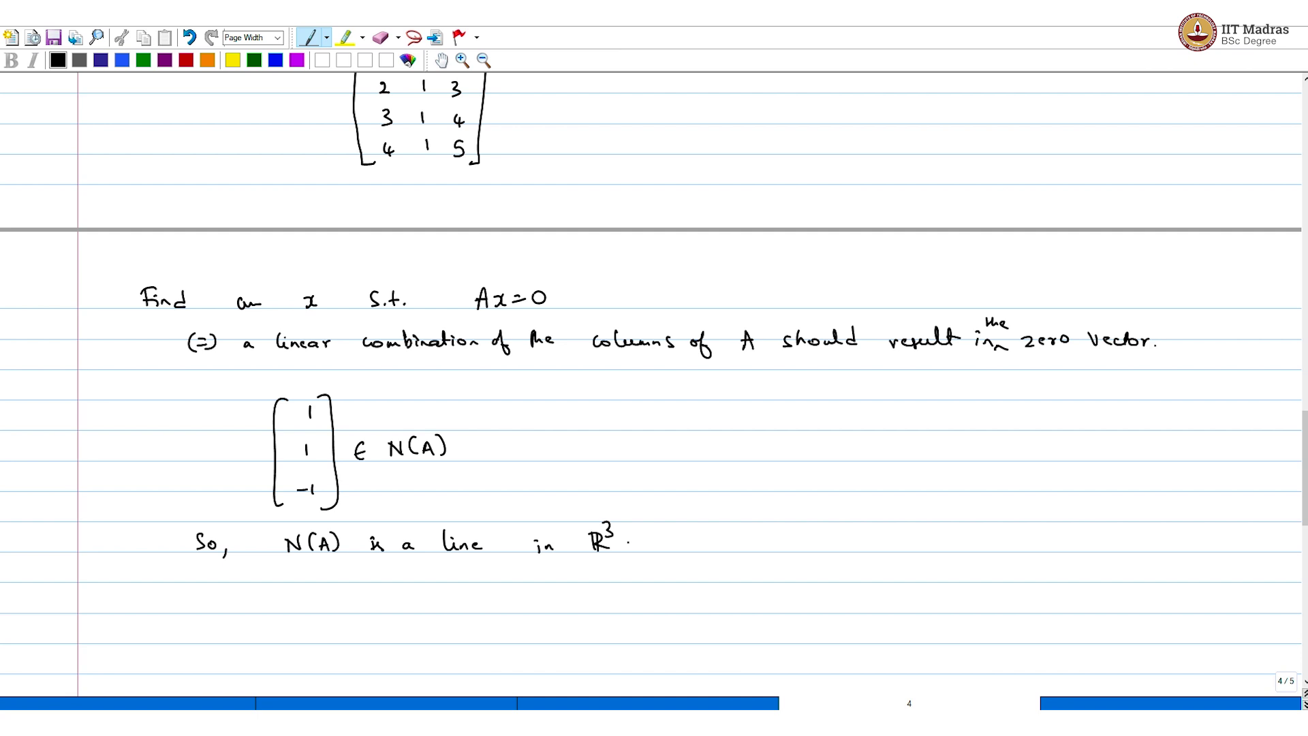
Now let us look at an example. For the same matrix here, so recall this matrix. So, A is as before, which is say 1 2 3 4, 1 1 1 1 and 2 3 4 5. I would encourage you to pause the video at this point and figure an x such that Ax = 0. So, find an x, such that Ax = 0. So, the point is, if what I want that is equivalent to seeing linear combination of the columns of A should result in the zero vector, the zero vector.
Now what would be a valid linear combination? We know that column 1 + column 2 is column 3. So, if I add up two, first two columns and subtract the third column, I would get the zero vector. So, 1 1 - 1 belongs to null space of A. Got it. And so, you have to understand the dimensionality here. So, null space of A is a line in R3.
So, you are looking at columns of A. And there are three columns in this matrix A and we are looking at linear combinations. So, every entry in the null space belongs to R3. And now the question is, does it pan enter R3? No, it is just a line. This is all you get for the null space.
(Refer Slide Time: 10:12)
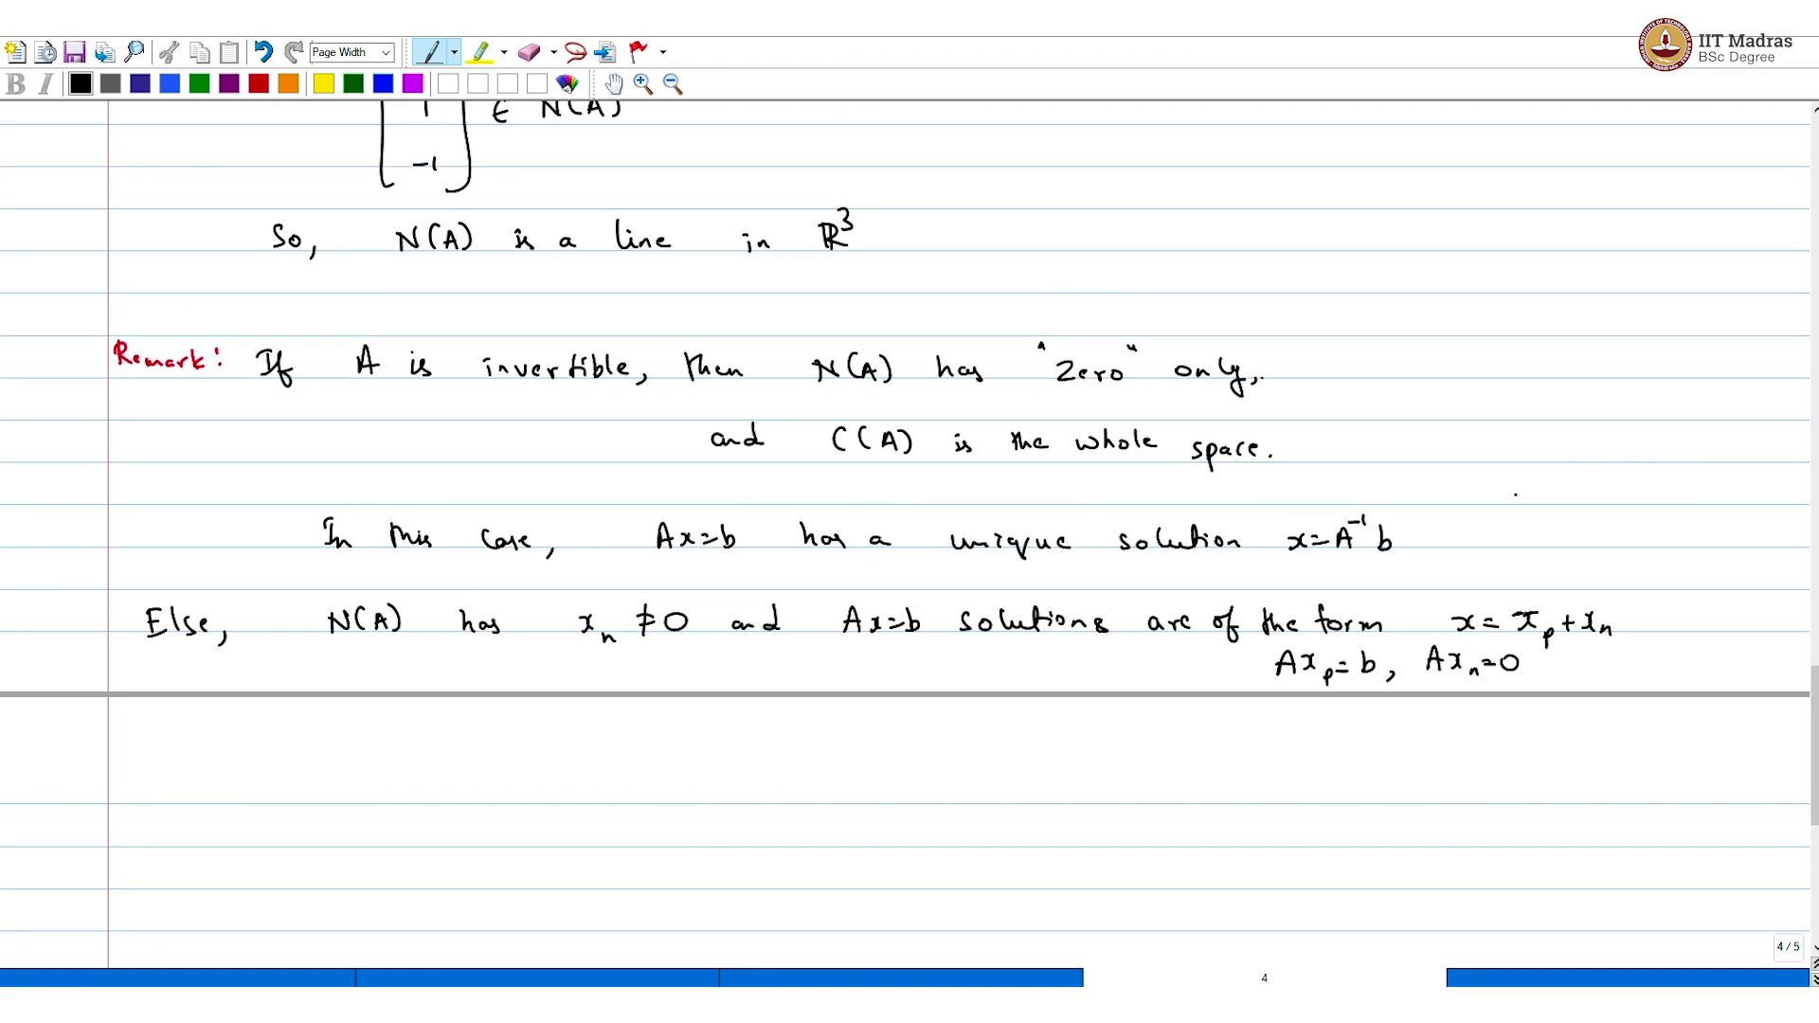
Just a quick remark, remark. If A is invertible, then null space of A has zero. And also, column space of A is the whole space. If that is not the case, then, I mean, and obviously, if column space of A is the whole space, then Ax = b has the, has a unique solution. In this case, Ax = b has a unique solution.
Else, null space of A has some vector, let us say xn that is non trivial, it is not the zero vector and Ax b, Ax = b solutions can be written or of the form x = xp + xn, where Axp = b and Axn = 0. So, much for the null space.
(Refer Slide Time: 12:18)
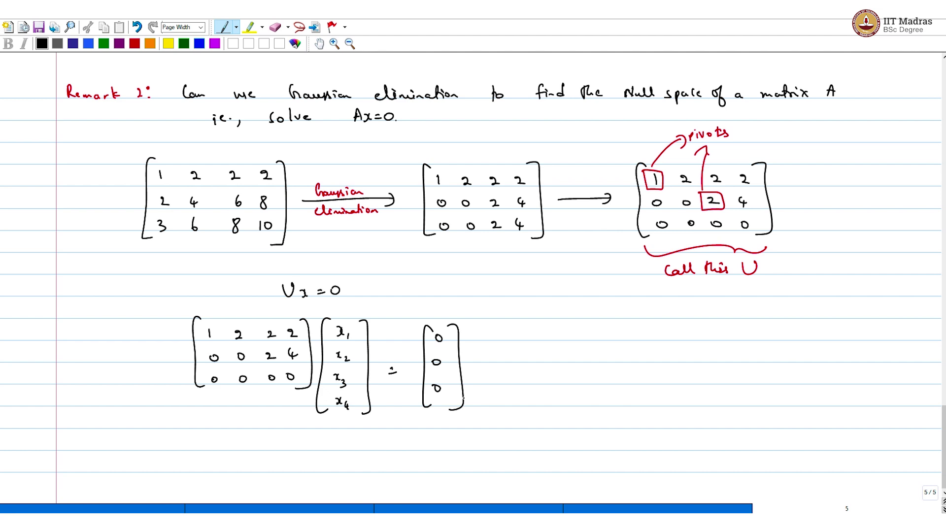
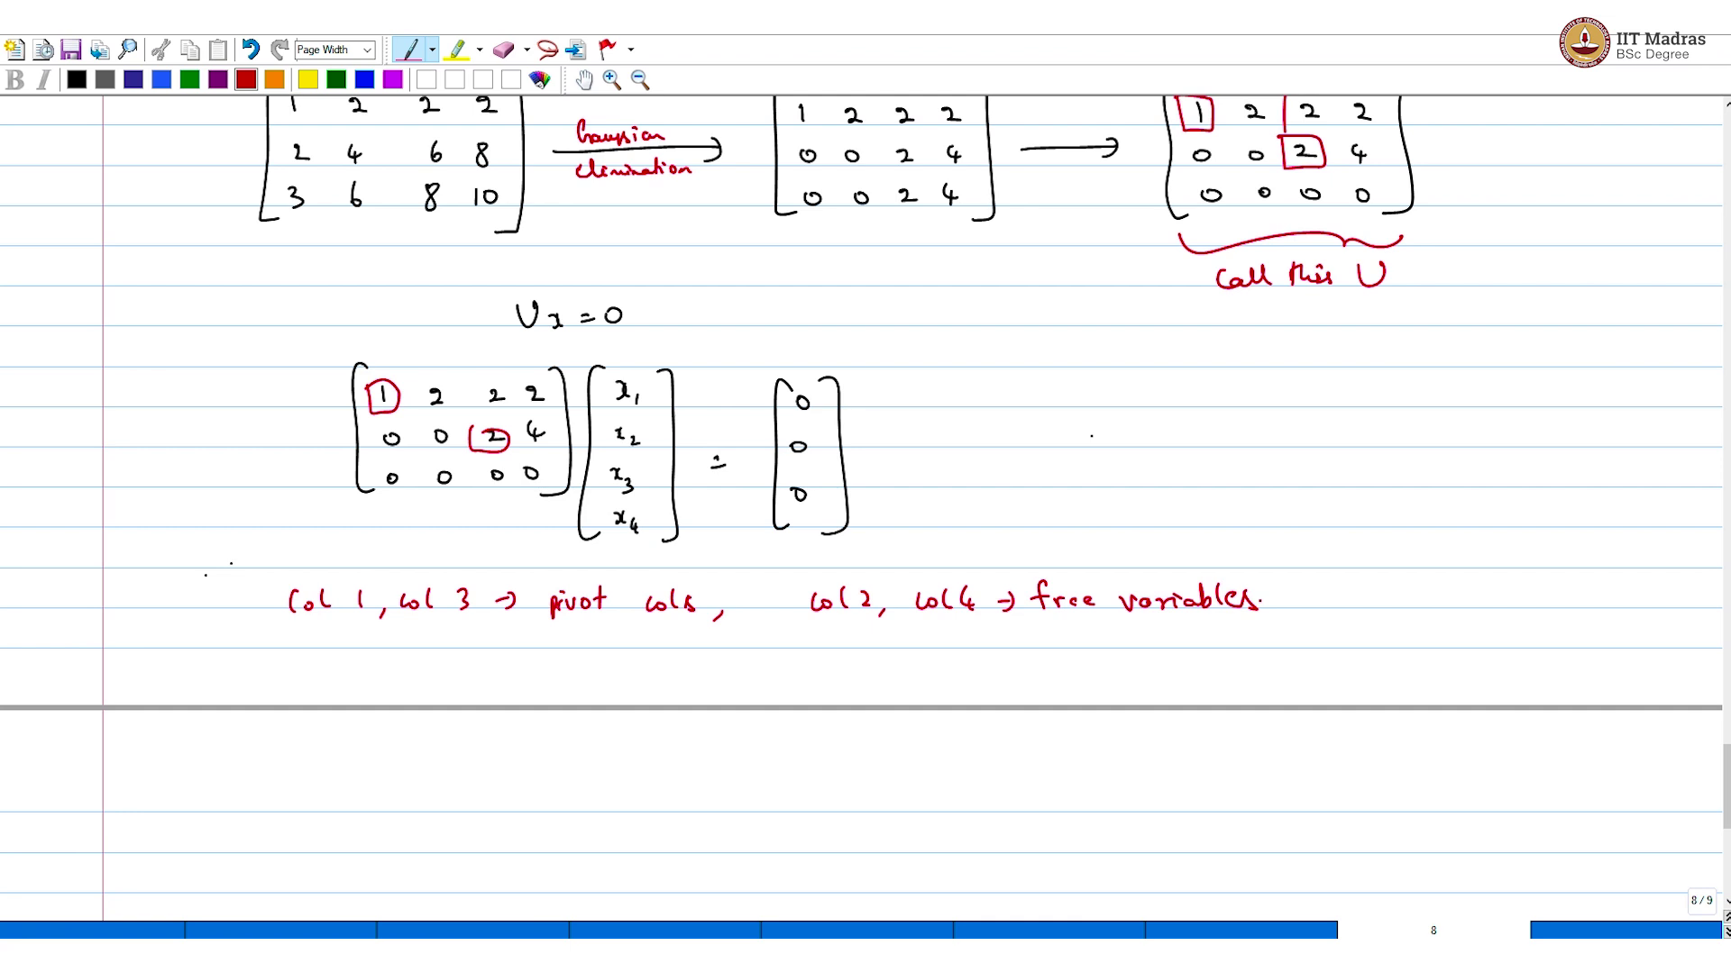
Remark 2, an use Gaussian elimination to find the null space of a matrix A. That is, you solve Ax = 0. That is what you do. I mean, I hope everyone has done Gaussian elimination before this, please go back and revise. For the sake of illustration, I will just give you an example without going through all the steps in detail.
Suppose you have the matrix say 1 2 2 2, 2 4 6 8, 3 6 8 10. Then you do Gaussian elimination. What you would get is 1 2 2 2, 0 0 2 4, 0 0 2 4. And some more steps would lead to 1 2 2 2, 0 0 2 4 and 0 0 0 0. So, now if I want to highlight the pivot columns, this would be it, pivots.
Now if I take this matrix, let us call this matrix U, call this U, then solving Ux = 0 is simple enough, which is like saying 1 2 2 2, 0 0 2 4, all zeroes to x1 x2 x3 x4, we want this to be. So, as I highlighted before, column 1, column 3 pivots columns and column 2, column 4 are the free variables.
(Refer Slide Time: 15:41)
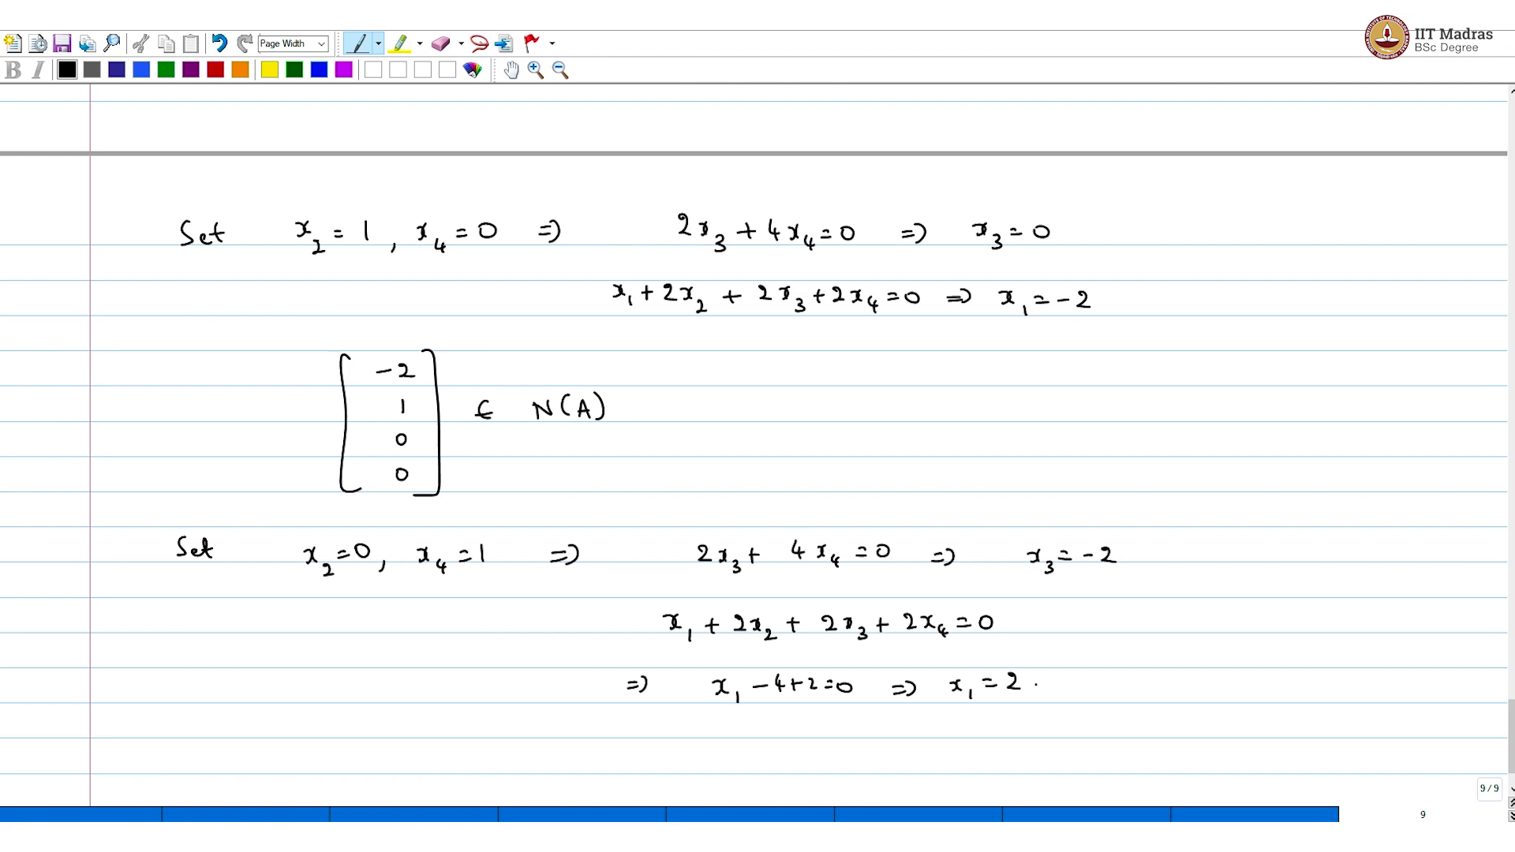
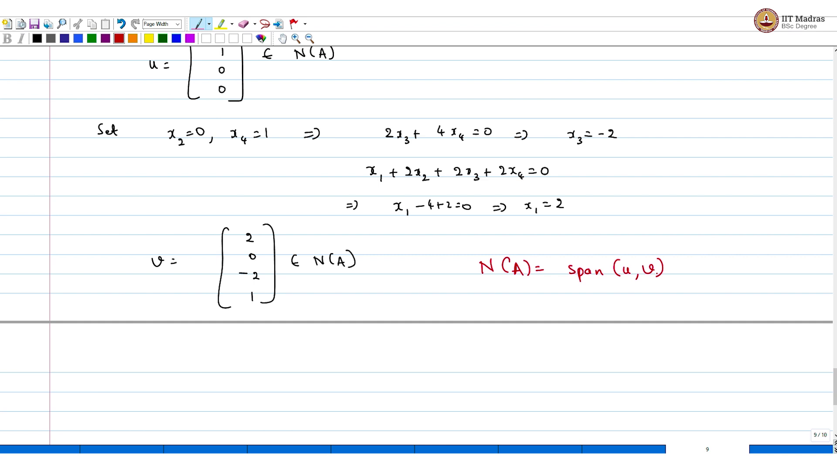
And here is the procedure. The way you go about figuring this is you take this free variables and set them to basis entry. So, x2 = 1, x4 = 0. If you do this, and if you solve the system, what you get is 2 x3 + 4 x4 = 0, which implies and also x1 +, which implies x3 = 0, because x4 = 0, x1 + 2 x2 + 2 x3 + 2 x4 = 0, which implies x1 = - 2.
And that gives us a first null space entry, which is x1 = - 2, x2 = 1, x3 = 0, x4 = 0. This belongs to null space of A, but this is not the only one, there are two free variables. So, what you have to do is, now the alternate choice is to set, set x2 = 0 and x4 = 1 implies, what you would get is 2 x3 + 4 x4 = 0, which implies x3 = - 2. So, you can pause the video and work out this on your own, they are fairly straightforward.
And then if you write down the other equations, x1 + 2 x2 + 2 x3 + 2 x4 = 0. This would imply x1 - 4 + 2 = 0, which is the same as x1 = 2 and that gives us the second entry. So, the other entry that belongs to a null space is, let us called this u. The other entry is v is a 2 0 - 2 1 belongs to null space of A, which is so the bottom line is null space of A is the span of u, v.
(Refer Slide Time: 18:00)
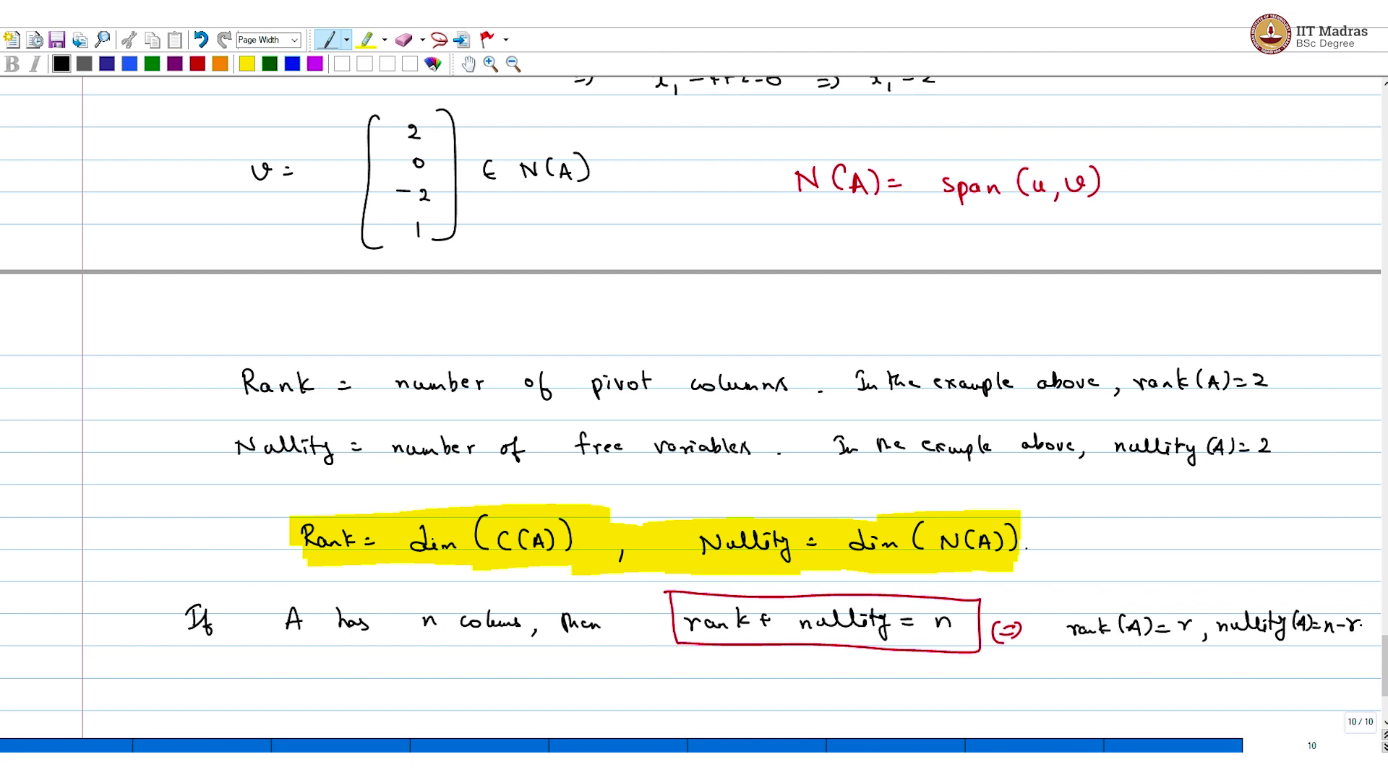
Now, this quantity rank you might have learned before, so, the rank is the same as number of pivot columns. The example above rank of A = 2 and the nullity is the number of free variables and the example above, nullity A = 2. So, rank = dimension of column space of A, and nullity = dimension of null space of A. If A has n columns, then rank + nullity = n, which is equivalent to saying rank of A = r, same as nullity of A = n - r.
So, this is the rank nullity theorem, I hope things are clear. I will not delve deeper into this, but I hope students have got a reasonable idea of the rank of a matrix and the nullity of a matrix and how to go about finding it, in particular, the underlying subspaces are the column space and column space and the null space. So, these are the quantities that are important.
(Refer Slide Time: 20:44)
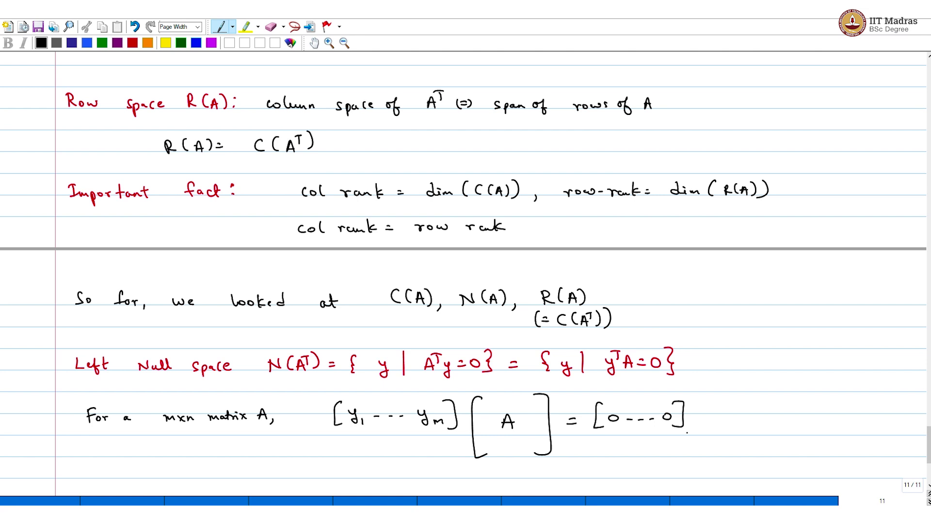
The other space is the row space, the next space that you have to look at is row space. And this is nothing but the column space of A transpose which is this, or equivalent T span of rows of A. So, R of A is equal to column space of A transpose. And the important fact is this, on this important fact. This goes without proof; we have seen this proof before.
Column rank = dimension of column space of A. Row rank = dimension of the row space. And important fact is column rank = row rank. So far, we looked at column space of A, null space of A, and also row space of A, which is equal to column space of A transpose. So, you can guess the very next space that you want to look at which is the null space of A transpose, which is called the left null space.
(Refer Slide Time: 22:31)
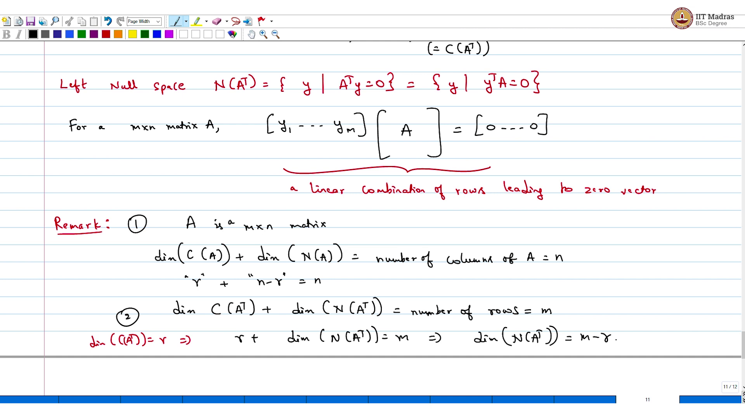
It is null space of A transpose. So, that, by definition is a set of all y's such that A transpose y = 0 or equivalently set of all y's such that y transpose = 0. Which is like saying that if I want to if A is m cross n matrix in the matrix for a m cross n matrix, what you are looking at is y1 until ym multiplying A and we want this to result in zeroes.
So, looking at, a linear combination of rows that results in the zero entry. So, this is like saying linear, linear combination of rows leading to zero vector. So that is the left null space. I will probably look at another example again to illustrate this four subspaces. Please pause and go back and look at the definitions carefully if you are encountering this for the first time.
Now a remark, is m cross n matrix. Row dimension of column space of A + dimension of null space of A, we know is the number of columns, is the number of columns of A, which is equal to m. Which is like saying that r + n - r = n. Now if you apply the same to A transpose, what you would get is dimension of column space of A transpose, + dimension of null space of A transpose = the number of rows. And that is m.
But we know dimension of column space of A transpose = the rank implies r + dimension of null space of A transpose = m which implies dimension of null space of A transpose is m - r.
(Refer Slide Time: 26:04)
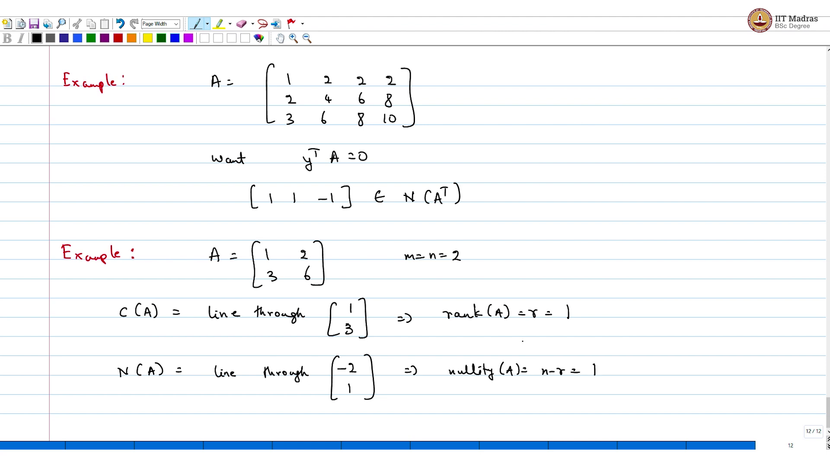
And if you look at, for example, let us take a simple example. By hand we can calculate this, without going through Gaussian elimination. Imagine A is 1 2 2 2, 2 4 6 8, 3 6 8 10. And I want a linear combination of the rows, what I want, want y transpose A = 0. So, I would encourage you to pause the video at this point and figure this y. I am going to give the answer, the answer is, you can say that the third column is just the sum of the first two and so, this is the solution.
I am going to do another example, much simple, just to make all the spaces explicit without going through Gaussian elimination. Say 1 2, 3 6. So, m = n = 2. What is the rank? So, the first thing, what is the column space of A? If you look at this pretty simple. The second column is just two times the first. So, column space of A is just the line through 1 , 3 implies, rank of A = r = 1.
What is the null space of A? What is the one entry that belongs to the null space? So, pause at this point, again, figure this null space on your own. I am going to give the answer. So, if I take - two times the second, first column and one times the second column that would belong there, they will not be any more linear independent vectors because rank of A is 1 and there are two columns, there is just one more entry left. So, this is the line through - 2, 1 implies nullity of A = n - r = 1.
(Refer Slide Time: 29:08)
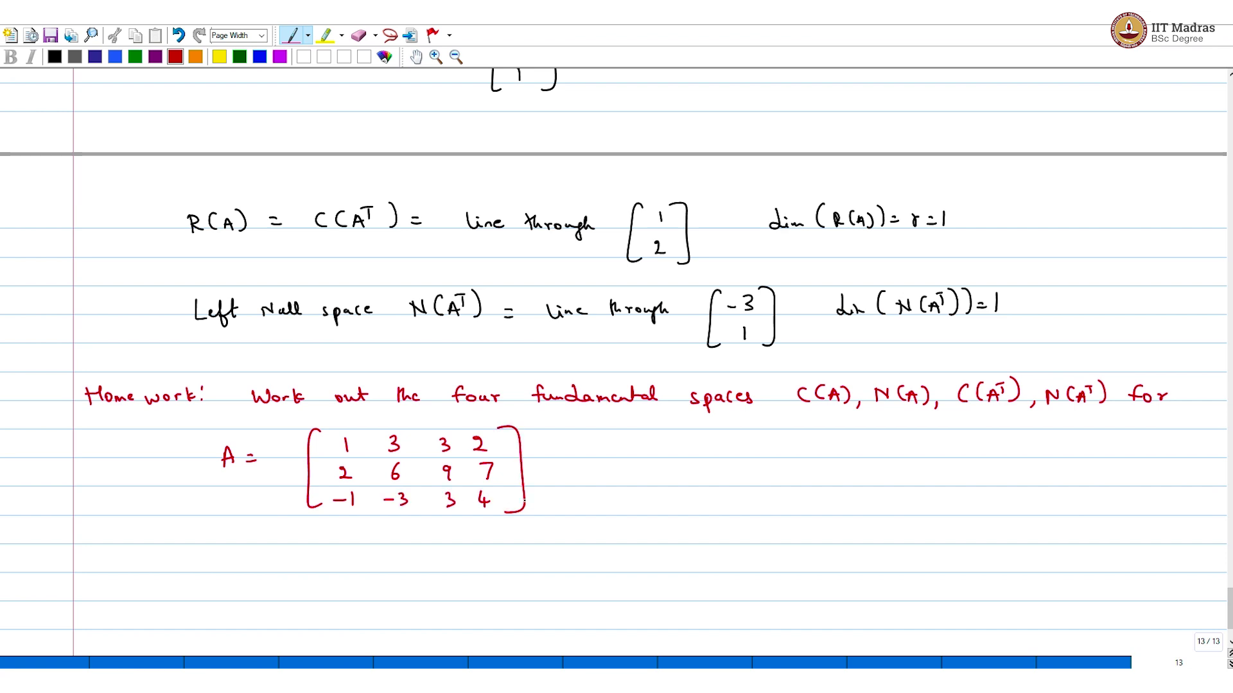
Now for the same matrix, what is the row space, is equal to column space of A transpose. And in this you can see, let us go up a little again, it does not change much. So, one dimensional quantity line through 1 2 again dimension of row space of A = r = 1. Now you are left with the left null space, which is null space of A transpose. This you can check is the line through and throughout you just look at this, the answer will be apparent, - three times the first row and once one times the second row will give you the zero entry. Dimension of null space of A transpose = 1.
No, I will give you folks a homework here, homework. Work out the four fundamental subspaces which is column space of A, null space of A, column space of A transpose and null space of A transpose for the following matrix which is A =, you will have to do Gaussian elimination, do some work reduce it to the row equivalent form and then things will be apparent. So, this is your matrix.
So, a quick recap before we end this lecture. So, in this lecture, what we did was to understand what the four fundamental subspaces associated with a matrix are, and these are the column null space, row space and the left null space. What we did was to understand how to, how the dimensions of these relate in particular, if you look at, I mean the dimension of a column space is the well-known quantity, which is rank and dimension of the null space is the nullity. And if I add these two numbers, which is the rank and nullity, we would get the number of columns.
And on the row side, you have the dimension of the row space, which is also the rank of a matrix which is a well-known linear algebra theorem. Dimension of the row space is the column space. But if I add the dimension of the row space, which is the rank and the dimension of the null space, null space, left null space, then I would get the number of rows, this other two things and then we looked at an example, where we worked out, we characterised the four fundamental subspaces by taking a simple enough matrix and we understood what their dimensions are and we characterised them by providing the basis.

